Learning Target Progression
The Standards used in these examples do not necessarily follow a progression of a single standard at a particular grade level, instead, the focus should be on the progression of how standards and their subsequent learning targets can have effect in the classroom.
State or National Level of Standard
Describe how a particular story’s or drama’s plot unfolds in a series of episodes as well as how the characters respond or change as the plot moves toward a resolution.

Local Teacher Friendly Targets
The learner will analyze how a particular story’s or drama’s plot unfolds in a series of episodes by describing how the characters respond or change as the plot moves toward a resolution.
Local Student Friendly Targets
I can describe a story in a series of episodes (incidents).
I can analyze the plot of a story or drama by tracing its progression.
I can describe how the characters respond or change as the plot unfolds.

The Targets in Action
Step 1
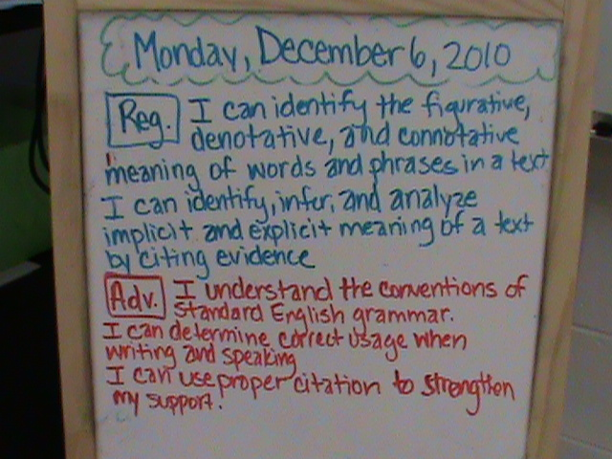
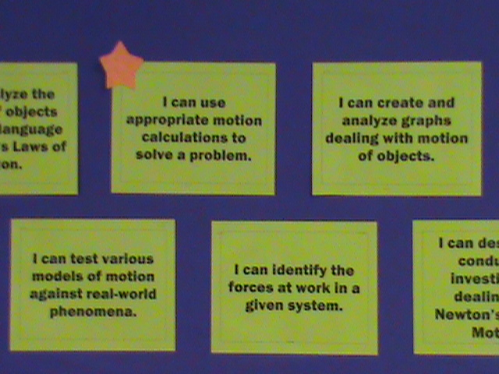
Teacher Writes the Targets on the Board

Step 2
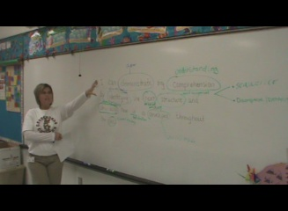
Partial Teacher Led Review of Targets with Students

Step 3
Complete Teacher Deconstruction of Learning Targets
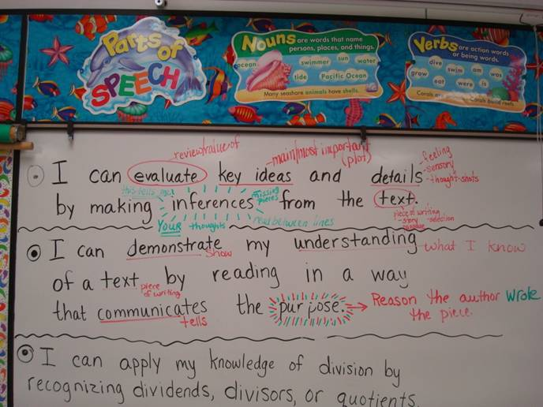

Step 4
Student Led Deconstruction of Learning Targets- Students are the end user

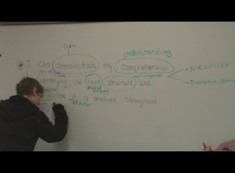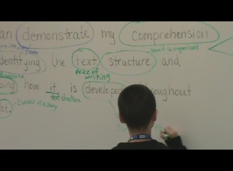

Moving Past Deconstruction
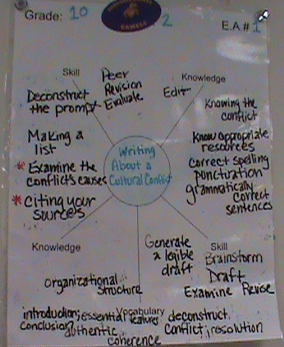
Student Led Deconstruction and Unpacking of Assessments Before Learning- Students are the Ultimate end users

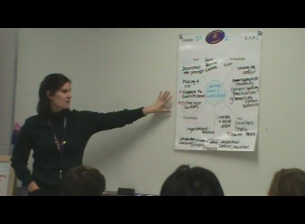

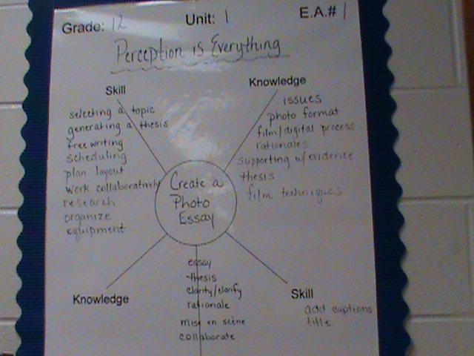

Additional Deconstructed Learning Target Examples- All can be enlarged to show
