Directions for setting up an Everyday Math teacher account.
- Email lori.harpold@campbell.kyschools.us or Melanie.schafer@campbell.kyschools.us to obtain the master codes for your grade level.
- Go to https://connected.mcgraw-hill.com/connected/legacyLogin.do
- Clink on .
- Type FZDWENJ as your registration code and input any other information.
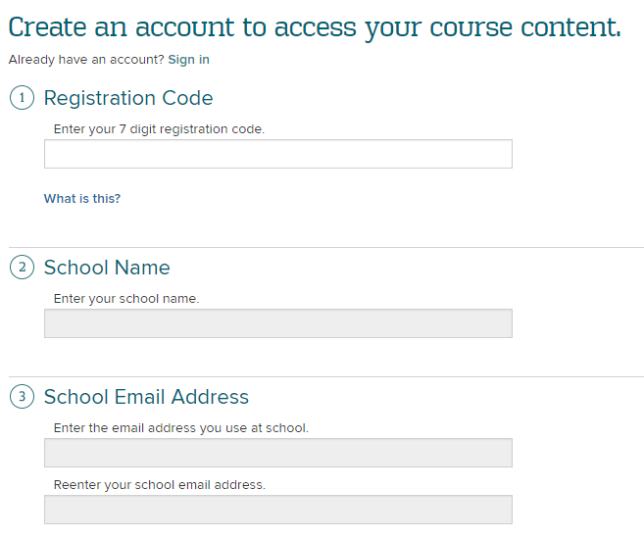
- Click Create Account at the bottom of the page.
- Input the Master Code from the email.
